Medical Conditions Policy
Policy Statement:

Sandon Point Children’s Centre aims to effectively care for and manage children with medical conditions including asthma, diabetes, epilepsy or a diagnosis that the child is at risk of anaphylaxis, in accordance with the Education and Care Services National Regulations 2011.

Strategies, Practices and Procedures:

The management of medical conditions at Sandon Point Children’s Centre is of the utmost importance to our service. This policy requires certain parties to perform specific duties when it comes to medical conditions.

Parent/Guardian Duties:

If a child is enrolled at the service who has a medical condition the parent/guardian needs to do the following:
- Provide a medical management plan for their child
- In consultation with the service develop a risk minimisation plan:
- Ensuring risks are assessed and minimised
- Ensuring practices and procedures in relation to safe handling, preparation, consumption and service of food are developed and implemented.
- Ensuring practices and procedures to notify parent/guardian of any known allergens that pose a risk to the child, and developing and implementing strategies for minimising the risk.
- Developing practices and procedures to ensure that all educators can identify the child, the child’s medical management plan and the location of the child’s medication.
- Developing practices and procedures to ensure that the child does not attend the service without medication prescribed by the child’s medical practitioner.
- In consultation with the Service develop a communications plan to ensure that:
- Educators and volunteers are informed about the medical management plan and risk minimisation plan of the child.
- Any changes to the medical plan, risk minimisation plan and communication plan and how this is to occur.

Approved Provider Duties:

If a child is enrolled at the service who has a medical condition, the Approved Provider needs to do the following:
- Inform the Nominated Supervisor, educators, educators and volunteers of how to manage the medical condition.
- Ensure all educators sign, that they have read the child’s medical management plan, risk minimisation plan, and communications plan
- Develop a risk minimisation plan in consultation with the child’s parent/guardian
- Develop a communications plan in consultation with the child’s parent/guardian

Asthma Management
Asthma is a breathing problem that affects many children in Australia. Asthma can be managed effectively but there is no known cure. Children with asthma have inflamed and sensitive airways (breathing tubes) in their lungs. When exposed to certain triggers the airways react abnormally and become narrow on the inside. As a result, asthma symptoms are experienced. This narrowing is due to swelling of the inside lining of the airways, an increase of mucus (phlegm) inside the airways, and tightening of the muscles around the outside of the airways.
Triggers:
Asthma symptoms can be triggered by a number of factors. It is common for children with asthma to have more than one trigger factor, but it is important to understand that asthma triggers may not be the same for each child. Avoiding or minimising exposure to known asthma triggers of individual children with asthma is the desired aim. Common triggers include:
- Exercise induced asthma
- Colds
- Smoke
- Allergens including dust mites, animal hair, dust and pollen
- Weather, ie changes in humidity and temperature, wind and thunderstorms.
- Emotions such as anxiety or stress.

To minimize the impact of triggers on the children at the centre the educators at the service will:
- monitor weather conditions and local news for warnings about coming weather conditions that can induce asthma.
- restrict children to indoor play in the case of poor air quality due to pollution, ie smoke from bush fires
- ensure children warm up before engaging in strenuous physical activity.
- restrict children from strenuous physical activity when they are recovering from a cold.
- ensure that a preventor medication is taken on excursions.

Symptoms:
Educators should be aware of the symptoms of asthma in children. They are:
- shortness of breath / difficulty in breathing
- wheezing
- coughing (dry)
- tightness in the chest or a sore tummy

Asthma Medicines
Medicines used in the treatment and management of asthma are those that relax the tight muscles around the airways (relievers) and reduce or prevent inflammation of the lining inside the airway (preventers). Asthma medicines that are used in Asthma First Aid are those that belong to the RELIEVER group and therefore most relevant to the school setting, Some reliever medicines are Salbutamol (Ventolin® , Asmol® , Airomir® ), & Terbutaline (Bricanyl® )

Asthma Flare-Ups
An asthma flare-up (asthma attack) can occur quickly, or develop over a few hours or days. It is indicated by Asthma symptoms that:
• start up and are worse than usual
• respond to asthma first aid medicine but come back again quickly
• do not respond to the usual asthma first aid medicine

It is important that asthma first aid is commenced immediately even for the mildest of asthma flare-ups, as symptoms can worsen quickly. Follow the child’s individual written asthma first aid instructions or Nationally Recognised Asthma First Aid procedure. (See below)

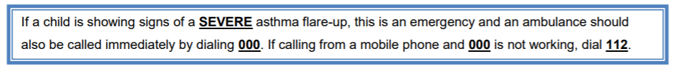
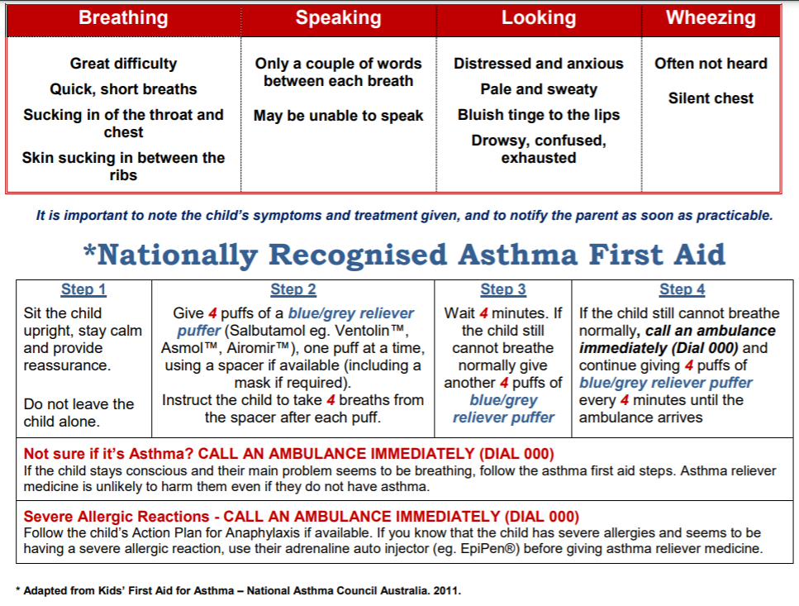
Using a Spacer Device
A spacer device helps children with asthma to use their puffers (aerosol inhalers or metered dose inhalers) effectively. It is highly recommended that spacers be used by all children who require a puffer, as this will allow more medication to be delivered directly to the airways.
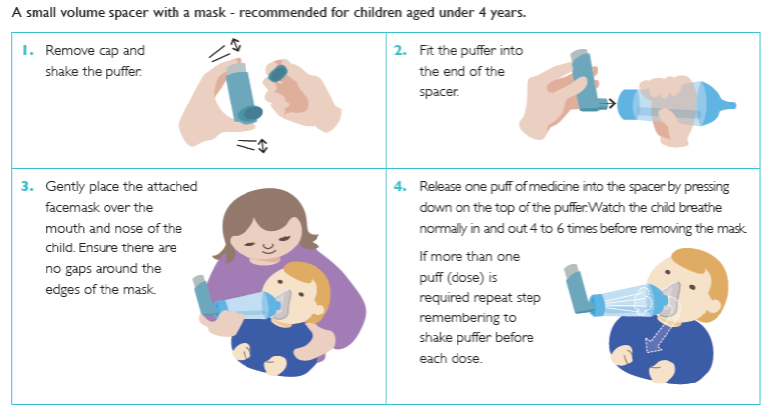
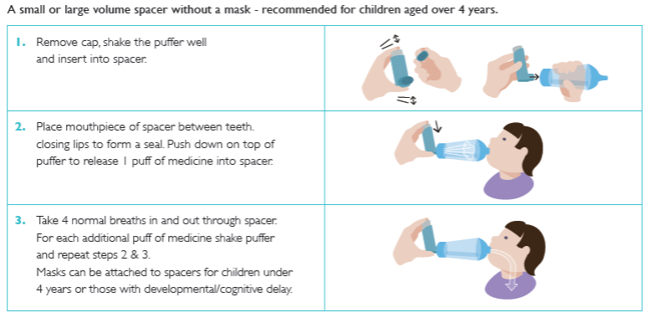
Epilepsy Management
Epilepsy is a common, serious neurological condition characterised by recurrent seizures due to abnormal electrical activity in the brain. While about 1 in 200 children live with epilepsy, the impact is variable – some children are greatly affected while others are not. “Epilepsy is unique: There are virtually no generalisations that can be made about how epilepsy may affect a child. There is often no way to accurately predict how a child’s abilities, learning and skills will be affected by seizures. Because the child’s brain is still developing, the child, their family and doctor will be discovering more about the condition as they develop. The most important thing to do when working with a child with epilepsy is to get to know the individual child and their condition. All children with epilepsy should have an Epilepsy Management Plan”.

Types of Seizures
Absence Seizure:
Occurring mostly in children, this consists of brief periods of loss of awareness, most often for less than 10 seconds. Some children can experience these types of seizures multiple times during the day which may compromise learning. Absence seizures can be mistaken for day-dreaming.

Focal (previously called simple or complex partial) Seizures:
Focal seizures start in one part of the brain and affect the area of the body controlled by that part of the brain. The symptoms experienced will depend on the function that the focal point controls (or is associated with). Focal seizures may or may not cause an alteration of awareness. Symptoms are highly variable and may include lip smacking, wandering behaviour, fiddling with clothes and feeling sick, ‘edgy’ or strange Focal seizures can progress into a generalised seizure.

Generalised Seizure:
Both sides of the brain are involved and the person will lose consciousness. A Tonic Clonic seizure is one type of generalised seizure.

Tonic Clonic Seizure:
A convulsive seizure with loss of consciousness, muscle stiffening, falling, followed by jerking movements. These types of seizures are no longer called ‘grand mals’.

Triggers
Seizures may occur for no apparent reason, but common triggers include: forgetting to take medication, lack of sleep, other illness, heat, stress/boredom, missing meals and dehydration. Flashing or flickering lights can trigger seizures in about 5% of people living with epilepsy.
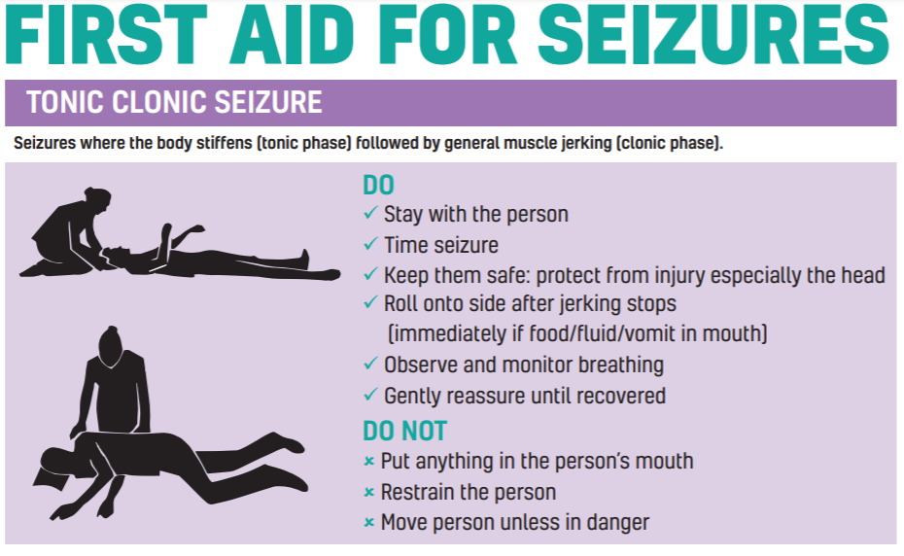
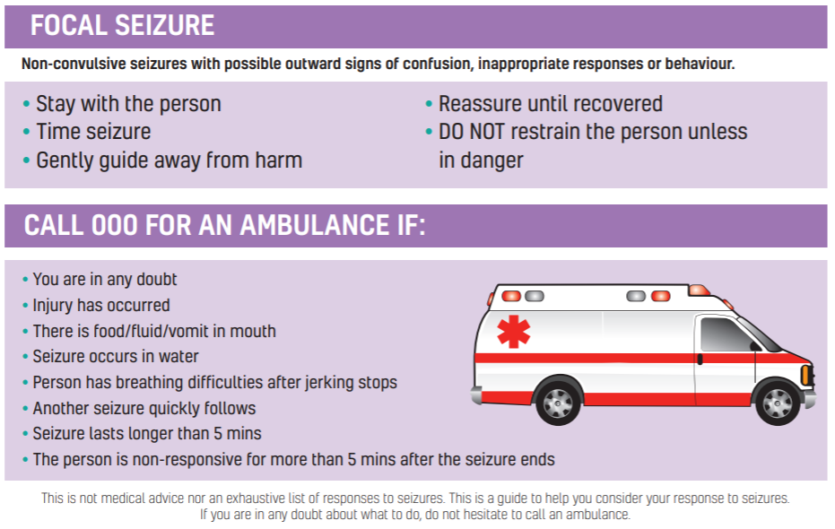

Links to the Education and Care Service National Regulations 2011 and National Quality Standard 2011

Regs | 85 | Incident, injury, trauma and illness policies and procedures
 | 86 | Notification to parents/guardians of incident, injury, trauma and illness
 | 87 | Incident, injury, trauma and illness record
 | 89 | First aid kits
 | 90 | Medical conditions policy
 | 91 | Medical conditions policy provided to parents/guardians
 | 92 | Medication record
 | 93 | Administration of medication
 | 94 | Exception to authorisation requirement—anaphylaxis or asthma emergency
 | 95 | Procedure for administration of medication
 | 96 | Self-administration of medication
 | 136 | First aid qualifications
 | 168 | Education and care services must have policies and procedures
 | 173 | Prescribed information to be displayed
 | 176 | Time to notify certain information to Regulatory Authority
 | 246 | Anaphylaxis training
 | 247 | Asthma management training

QA | 2.1.1 | Each child’s wellbeing and comfort is provided for, including appropriate opportunities to meet each child’s need for sleep, rest and relaxation
 | 2.1.2 | Effective illness and injury management and hygiene practices are promoted and implemented
 | 2.1.3 | Healthy eating and physical activity are promoted and appropriate for each child
 | 2.2.1 | At all times, reasonable precautions and adequate supervision ensure children are protected from harm and hazard
 | 2.2.2 | Plans to effectively manage incidents and emergencies are developed in consultation with relevant authorities, practised and implemented

The Approved Provider/Licensee/Director/Nominated Supervisor will ensure that this policy is maintained and implemented at all times.

Measuring Tools:
Accident/Injury Register
Links to Other Policies:
Anaphylaxis and Allergy Management Policy
Diabetes Policy
Accident and Injury Prevention Policy
Management of Infectious Diseases and Exclusion Policy
Hygiene Policy
Administration of Medication Policy

Policy Created: Jan 2012
Policy Reviewed: Sept 2023
Policy Review Date Sept 2024

Sources:
Education and Care Services National Regulation 2011
Education and Care Services National Law Act 2010
Guide to the National Quality Standards 2011
National Quality Standards 2011
https://www.schn.health.nsw.gov.au/files/attachments/asthma_management_information_for_childrens_service_staff.pdf
https://www.ecms.org.au/sites/default/files//ECMS%20policies%20and%20procedures/2.15%20Epilepsy.pdf accessed Sept 2023

SANDON POINT CHILDREN’S CENTRE RISK MINIMISATION PLAN (ANAPHYLAXIS)

How well has the children’s service planned for meeting the needs of children with allergies who are at risk and with a medical condition requiring extra care?

1. Who are the children? | • List name and room location of each of the at risk child | Name:
2. What are they allergic to? | • List all of the known allergens and risk factors for each of the at risk children | Allergens:
 | • List potential sources of exposure to each known allergen and strategies to minimise the risk of exposure  • All educators are aware of where each child’s medical management plan and medication (including expiry) are located | - Sandon Point CC is a nut aware centre and there is a warning notifying all who attend that there may be children attending who are anaphylactic  - Information is written on each child’s medical management plan  - Any new information is communicated through staff meetings
3. Does everyone recognise the “at risk” children? | • List the strategies for ensuring that all educators, including relief educators and cooks, recognise each of the “at risk” children.  • Confirm where the child’s Medical Management Plan (including the child’s photograph) will be displayed | Medical management plans with photos are visible in all rooms. Relief educators/students are directed to these when they start work

DO FAMILIES AND EDUCATORS KNOW HOW THE SERVICE MANAGES THE RISK OF MEDICAL CONDITIONS?

STRATEGIES | HOW, WHO AND WHEN
Record when each family of an at risk child is provided a copy of the service’s Anaphylaxis policy on their enrolment form | Director/Nominated Supervisor  At the enrolment and when we update the policy
Record when each family member provides appropriate medication | All educators.  On medication form
All educators, including relief educators, know where medication and medical management plans are kept for each at risk child | The service’s Epipen is located in the first aid cabinet in the middle classroom room and is accessible to educators at all times
Regular checks of the expiry date of each child’s medication are undertaken by nominated staff member and the families of each at risk child. | Expiry dates are checked prior to administration by the room leader and families are to be notified in writing by the Director when they need to up-date their medication.
Procedures to be followed to minimise the risk of exposure to a known allergen.  • Food packaging of risk foods is kept separate and in labelled containers  • Food Safety and Hygiene Policy will be followed by educators when serving food | All educators
If the food allergens change. | Families will notify educators verbally and in writing as soon as possible and educators will document the changes on the medical management plan
Ensure all families are aware of the policy that no child who has been prescribed an EpiPen is permitted to attend the service without that EpiPen | Director/Nominated Supervisor and all educators  As per policy the Epipen stays at the centre
The service displays the ASCIA generic poster in key locations, and emergency call information posters near all telephones | Director/Nominated Supervisor  ASCIA posters up in kitchen
Medication is taken on all outings attended by the at risk child | All educators attending excursion
The service ensures there is an educators with first aid training on duty at all times | All educators have up to date anaphylaxis and asthma training.

DO ALL EDUCATORS KNOW HOW THE CHILD’S SERVICE AIMS TO MINIMISE THE RISK OF A CHILD BEING EXPOSED TO AN ALLERGEN?
Think about times when the child could potentially be exposed to allergens and develop appropriate strategies, including who is responsible for implementing them

STRATEGIES | IMPLEMENTATION
Special event menus are planned in conjunction with parents/guardians of at risk children | • Food for the at risk child is prepared according to their parents’/guardians’ instructions to avoid the inclusion of food allergens  • As far as practical the food on the menu for all children should not contain ingredients such as milk, egg and peanut/nut products to which the child is at risk The menu is prepared with parents/guardians advice and medical management plan, avoiding inclusion of peanuts and eggs  • The “at risk” child should not be given food if the label for the food states that the food may contain traces of a known allergen
Hygiene procedures and practices are used to minimise the risk of contamination of surfaces, food utensils and containers by food allergens | • Educators to use tongs when serving the children  • Separate containers for food for children with allergy
Consider the safest place for the at risk child to be served and consume food, while ensuring they are socially included in all activities, and ensure this location is used by the child | For babies, thi might mean the allocation of their own high chair at the table. For other children, they can use their own lunchboxes to access servings.
Service develops procedures for ensuring that each at risk child only consumes food prepared specifically for him/her | Families label individual meals with the child’s name
NO FOOD is introduced to a baby if the parent/guardian has not previously given this food to the baby | Director/Nominated Supervisor  Families informed of this at enrolment.
Ensure each child enrolled at the service washes his/her hands before and after eating, using the bathroom as well as before and after playing outdoors. | Educators encourage the children’s to wash their hands.
Teaching strategies are used to raise awareness of all children about anaphylaxis and no food sharing with the at risk child/ren and the reason for this | Educators discuss this with children at mealtimes, educators sit with children during mealtimes as well
Bottles, other drinks and lunch boxes provided by the family of the at risk child should be clearly labelled with the child’s name | Educators to check all food containers/bottles are clearly labelled.
Educators may consume foods that could contain ingredients dangerous to at risk children | Educators will wash hands and rinse mouth before returning to work

DO RELEVENT PEOPLE KNOW WHAT ACTION TO TAKE IF A CHILD HAS AN ANAPHYLACTIC REACTION?

ACTION REQUIRED | BY WHOM
Know what each child’s Action Plan says and implement it | All the educators
Who will administer medication and stay with the child? | Familiar educators will stay with the child in order to minimise distress of child
Who will telephone the ambulance and the parents/guardians? | Director/Nominated Supervisor or Responsible Person on duty as per roster
Who will let the ambulance officers into the service and take them to the child | Director/Nominated Supervisor or Responsible Person on duty as per roster
Who will ensure the supervision of the other children? | All educators in the room not administering medication
All educators with responsibilities for at risk children have undertaken anaphylaxis management training and regular practise sessions | All educators have current anaphylaxis management training. Please see educators training records on file.

PARENT/GUARDIAN INPUT TO RISK MINIMISATION PLAN
Please sign to acknowledge that you have read and understood this document.
Director:  Date: | Parent/Guardian:  Date:
Please sign to give consent for your child’s action plan to be displayed around the centre.
Parent/Guardian: | Date

We, the undersigned, acknowledge that we have read and understood the medical management plan, risk minimization plan and communications plan for _________________________________________________
Educators Name | Date | Signature
Communication Plan for Sandon Point Children’s Centre in relation to the Medical Conditions Policy.

Sandon Point Children’s Centre’s Medical Conditions Policy is communicated with educators during their induction to the centre.
They are directed to look at the medical conditions quick list and action plans in the room that they will be working in for the day and alerted to children who are covered by these.
The medical conditions policy is communicated with families upon enrolment.
Parents/Guardians will provide all information on enrolment forms, a copy of a medical action plan and discuss the medical condition with the director/ administration officer. The director will then pass this information onto an educators working with the child and they will inform all educators in that room.

Communication plan
Child’s name: _________________________________________________

Medical condition: _________________________________________________

Date centre was notified: _________________________________________________

Who made the notification: _________________________________________________

Who received the notification: _________________________________________________

Medical action plan given: Yes/Not yet (please circle)

Date received: _________________________________________________

Discussion about medication and it needing to be at the centre at all times with
_________________________________________________

Date medical action plan displayed and educators notified: ____________________

Who was notified: _________________________________________________

By whom: _________________________________________________

Who are the educators in the room & what date was it communicated: ____________________________________________________________________________

____________________________________________________________________________

____________________________________________________________________________

Date of staff meeting where it was discussed with all educators ____________________________________________________________________________

Further communication will be made on a report of parent/guardian contact form and kept in the child’s individual file.

SANDON POINT CHILDREN’S CENTRE RISK MINIMISATION PLAN (NEUROMUSCULAR DISORDER)

How well has the children’s service planned for meeting the needs of children who are at risk and with a medical condition requiring extra care?

1. Who are the children? | • List name and room location of each of the at risk child | Name:
2. What are the issues caused by the disorder? | • List all of the known issues and how they are addressed at the centre | Issues:  - Choking on food/drink is prevented by use of appropriate seating, drink bottles, food texture/consistency, training on feeding techniques with a speech therapist/OT.  - Aspiration of phlegm/food/drink is prevented by use of appropriate seating and positioning.
3. Does everyone recognise the “at risk” children? | • List the strategies for ensuring that all educators, including relief educators and cooks, recognise each of the “at risk” children. | Relief educators/students are directed to read the medical management plans of all children with medical conditions during their orientation and prior to working. Updates/changes are displayed on the educators room noticeboard.

DO FAMILIES AND EDUCATORS KNOW HOW THE SERVICE MANAGES THE RISK OF MEDICAL CONDITIONS?
STRATEGIES | HOW, WHO AND WHEN
Record when each family of an at risk child is provided a copy of the service’s Medical Conditions Policy on their enrolment form | Director/Nominated Supervisor  At the enrolment and when we update the policy
Record when each family member provides appropriate medication | All educators.  On medication form
All educators, including relief educators, know where medication and medical management plans are kept for each at risk child | Medications are to be stored in the centre’s kitchen.
Regular checks of the expiry date of each child’s medication are undertaken by nominated educator and the families of each at risk child. | Expiry dates are checked prior to administration by the room leader and families are to be notified in writing by the Director when they need to up-date their medication.
Procedures to be followed to minimise the risk of exposure to a known issue.  • Consultation with families to determine issues.  • Educators will consider known issues when developing the room’s program to ensure the child is protected from exposure | All educators
If the issues change. | Families will notify educators verbally and in writing as soon as possible and educators will document the changes on the medical management plan
The service displays emergency call information near all telephones | Director/Nominated Supervisor
Medication is taken on all outings attended by the at risk child | All educators attending excursions
The service ensures there is an educators with first aid training on duty at all times | All educators have up to date first aid training.

DO ALL EDUCATORS KNOW HOW THE CHILD’S SERVICE AIMS TO MINIMISE THE RISK OF A CHILD BEING EXPOSED TO A KNOWN ISSUE?
Think about times when the child could potentially be exposed to issues and develop appropriate strategies, including who is responsible for implementing them

STRATEGIES | IMPLEMENTATION
Special events are communicated through the newsletter with all families. | Families are given plenty of notice when a special event is being organized.  Families can suggest special events to include in the program that will not pose a risk to their child
Hygiene procedures and practices are used to minimise risk. The centre is cleaned daily by professional cleaners. | The service is cleaned daily by professional cleaners.
The centre will create a safe and inclusive physical environment | Director to source seating and mobility aids.
NO medication is to be administered by trainees, students or volunteers | Director/Nominated Supervisor  Trainees, students and volunteers are notified of this during induction process
Educators to take note of environmental conditions before moving to outdoor play areas.
To report illness in a timely manner | Educators will inform the family immediately if the child appears unwell, even if the symptoms appear unrelated to their asthma conditions.

DO RELEVENT PEOPLE KNOW WHAT ACTION TO TAKE IF A CHILD CHOKES?
ACTION REQUIRED | BY WHOM
Know what each child’s Action Plan says and implement it | All the educators
Who will administer first aid and stay with the child? | Familiar educators will stay with the child in order to minimise distress of child
Who will telephone the ambulance and the parents/guardian? | Director/Nominated Supervisor or Responsible Person on duty as per roster
Who will let the ambulance officers into the service and take them to the child | Director/Nominated Supervisor or Responsible Person on duty as per roster
Who will ensure the supervision of the other children? | All educators in the room not administering medication
All educators with responsibilities for at risk children have undertaken first aid training and regular practise sessions | All educators have current first aid training. Please see educators training records on file.
PARENT/GUARDIAN INPUT TO RISK MINIMISATION PLAN
Please sign to acknowledge that you have read and understood this document.
Director:  Date: | Parent/Guardian:  Date:
Please sign to give consent for your child’s action plan to be displayed around the centre.
Parent/Guardian: | Date

We, the undersigned, acknowledge that we have read and understood the medical management plan, risk minimization plan and communications plan for _________________________________________________
Educators Name | Date | Signature
Communication Plan for Sandon Point Children’s Centre in relation to the Medical Conditions Policy.

Sandon Point Children’s Centre’s Medical Conditions Policy is communicated with educators during their induction to the centre.
They are directed to look at the medical conditions quick list and action plans in the room that they will be working in for the day and alerted to children who are covered by these.
The medical conditions policy is communicated with families upon enrolment.
Parents/Guardians will provide all information on enrolment forms, a copy of a medical action plan and discuss the medical condition with the director/ administration officer. The director will then pass this information onto an educator working with the child and they will inform all educators in that room.

Communication plan
Child’s name: _________________________________________________

Medical condition: _________________________________________________

Date centre was notified: _________________________________________________

Who made the notification: _________________________________________________

Who received the notification: _________________________________________________

Medical action plan given: Yes/Not yet (please circle)

Date received: _________________________________________________

Discussion about medication and it needing to be at the centre at all times with
_________________________________________________

Date medical action plan displayed and educators notified: ____________________

Who was notified: _________________________________________________

By whom: _________________________________________________

Who are the educators in the room & what date was it communicated: ____________________________________________________________________________

____________________________________________________________________________

____________________________________________________________________________

Date of staff meeting where it was discussed with all educators ____________________________________________________________________________

Further communication will be made on a report of parent/guardian contact form and kept in the child’s individual file.

SANDON POINT CHILDREN’S CENTRE RISK MINIMISATION PLAN (ASTHMA)

How well has the children’s service planned for meeting the needs of children with asthma who are at risk and with a medical condition requiring extra care?

1. Who are the children? | • List name and room location of each of the at risk child | Name:
2. What are they allergic to? | • List all of the known triggers and risk factors for each of the at risk children | Triggers:
 | • List potential sources of exposure to each known trigger and strategies to minimise the risk of exposure  • All educators are aware of where each child’s medical management plan and medication (including expiry) are located | - Sandon Point CC is an asthma aware centre.  - Information is written on each child’s medical management plan  - Any new information is communicated through staff meetings
3. Does everyone recognise the “at risk” children? | • List the strategies for ensuring that all educators, including relief educators and cooks, recognise each of the “at risk” children.  • Confirm where the child’s Medical Management Plan (including the child’s photograph) will be displayed | Medical management plans with photos are visible in all rooms. Relief educators/students are directed to these when they start work

DO FAMILIES AND EDUCATORS KNOW HOW THE SERVICE MANAGES THE RISK OF MEDICAL CONDITIONS?

STRATEGIES | HOW, WHO AND WHEN
Record when each family of an at risk child is provided a copy of the service’s Medical Conditions Policy on their enrolment form | Director/Nominated Supervisor  At the enrolment and when we update the policy
Record when each family member provides appropriate medication | All educators.  On medication form
All educators, including relief educators, know where medication and medical management plans are kept for each at risk child | Asthma puffers and spacers are to be stored in the centre’s kitchen.
Regular checks of the expiry date of each child’s medication are undertaken by nominated educators and the families of each at risk child. | Expiry dates are checked prior to administration by the room leader and families are to be notified in writing by the Director when they need to up-date their medication.
Procedures to be followed to minimise the risk of exposure to a known trigger.  • Consultation with families to determine triggers.  • Educators will consider known triggers when developing the room’s program to ensure the child is protected from exposure | All educators
If the triggers change. | Families will notify educators verbally and in writing as soon as possible and educators will document the changes on the medical management plan
Ensure all families are aware of the policy that no child who has been prescribed an asthma preventer/reliever is permitted to attend the service without that asthma preventer/reliever | Director/Nominated Supervisor and all educators  As per policy the asthma preventer/reliever stays at the centre during the child’s attendance each day.
The service displays emergency call information near all telephones | Director/Nominated Supervisor
Medication is taken on all outings attended by the at risk child
The service ensures there is an educators with first aid training on duty at all times | All educators have up to date asthma management training.

DO ALL EDUCATORS KNOW HOW THE CHILD’S SERVICE AIMS TO MINIMISE THE RISK OF A CHILD BEING EXPOSED TO A TRIGGER?
Think about times when the child could potentially be exposed to triggers and develop appropriate strategies, including who is responsible for implementing them

STRATEGIES | IMPLEMENTATION
Special events are communicated through the newsletter with all families. | Families are given plenty of notice when a special event is being organized, ie chicken hatching program, to give families time to inform the centre if this would pose a risk to their child  Families can suggest special events to include in the program that will not pose a risk to their child
Hygiene procedures and practices are used to minimise risk. The centre is cleaned daily by professional cleaners. | The Director has replaced carpets with plastic mats.  The Director purchased a Dyson vacuum cleaner for the centre.
The centre will create a physical environment with furnishings that are asthma “friendly”.
NO medication is to be administered by trainees, students or volunteers | Director/Nominated Supervisor  Trainees, students and volunteers are notified of this during induction process
Teaching strategies are used to raise awareness of all children about asthma and what to do if they notice one of their friends is showing symptoms. | Educators discuss this with children at group times.
Educators to take note of environmental conditions before moving to outdoor play areas.
To report illness in a timely manner | Educators will inform the family immediately if the child appears unwell, even if the symptoms appear unrelated to their asthma conditions.

DO RELEVENT PEOPLE KNOW WHAT ACTION TO TAKE IF A CHILD HAS AN ASTHMA ATTACK?

ACTION REQUIRED | BY WHOM
Know what each child’s Action Plan says and implement it | All the educators
Who will administer medication and stay with the child? | Familiar educators will stay with the child in order to minimise distress of child
Who will telephone the ambulance and the parents/guardian? | Director/Nominated Supervisor or Responsible Person on duty as per roster
Who will let the ambulance officers into the service and take them to the child | Director/Nominated Supervisor or Responsible Person on duty as per roster
Who will ensure the supervision of the other children? | All educators in the room not administering medication
All educators with responsibilities for at risk children have undertaken asthma management training and regular practise sessions | All educators have current asthma management training. Please see educators training records on file.

Communication Plan for Sandon Point Children’s Centre in relation to the Medical Conditions Policy.

Sandon Point Children’s Centre’s Medical Conditions Policy is communicated with educators during their induction to the centre.
They are directed to look at the medical conditions quick list and action plans in the room that they will be working in for the day and alerted to children who are covered by these.
The medical conditions policy is communicated with families upon enrolment.
Parents/Guardians will provide all information on enrolment forms, a copy of a medical action plan and discuss the medical condition with the director/ administration officer. The director will then pass this information onto an educator working with the child and they will inform all educators in that room.

Communication plan
Child’s name: _________________________________________________

Medical condition: _________________________________________________

Date centre was notified: _________________________________________________

Who made the notification: _________________________________________________

Who received the notification: _________________________________________________

Medical action plan given: Yes/Not yet (please circle)

Date received: _________________________________________________

Discussion about medication and it needing to be at the centre at all times with
_________________________________________________

Date medical action plan displayed and educators notified: ____________________

Who was notified: _________________________________________________

By whom: _________________________________________________

Who are the educators in the room & what date was it communicated: ____________________________________________________________________________

____________________________________________________________________________

____________________________________________________________________________

Date of staff meeting where it was discussed with all educators ____________________________________________________________________________

Further communication will be made on a report of parent/guardian contact form and kept in the child’s individual file.

PARENT/GUARDIAN INPUT TO RISK MINIMISATION PLAN
Please sign to acknowledge that you have read and understood this document.
Director:  Date: | Parent/Guardian:  Date:
Please sign to give consent for your child’s action plan to be displayed around the centre.
Parent/Guardian: | Date

We, the undersigned, acknowledge that we have read and understood the medical management plan, risk minimization plan and communications plan for _________________________________________________
Educators Name | Date | Signature

SANDON POINT CHILDREN’S CENTRE RISK MINIMISATION PLAN CDKL5 DEFICIENCY (NEURODEVELOPMENTAL DELAY AND EPILEPSY)
How well has the children’s service planned for meeting the needs of children who are at risk and with a medical condition requiring extra care?

1. Who are the children? | • List name and room location of each of the at risk child | Name:
2. What are the issues caused by the disorder? | • List all of the known issues and how they are addressed at the centre | Issues:  - Epileptic seizures can occur at any time which requires constant 1:1 supervision to manage safely.  - Increased appetite so monitoring food intake is important, especially ingestion of non-food items in the environment, ie bark chip.  - Choking on food/drink is prevented by use of appropriate seating, drink bottles, food texture/consistency, training on feeding techniques with a speech therapist/OT.  - Aspiration of phlegm/food/drink is prevented by use of appropriate seating and positioning.
3. Does everyone recognise the “at risk” children? | • List the strategies for ensuring that all educators, including relief educators, recognise each of the “at risk” children. | Relief educators/students are directed to read the medical management plans of all children with medical conditions during their orientation and prior to working. Updates/changes are displayed on the educators room noticeboard.

DO FAMILIES AND EDUCATORS KNOW HOW THE SERVICE MANAGES THE RISK OF MEDICAL CONDITIONS?

STRATEGIES | HOW, WHO AND WHEN
Record when each family of an at risk child is provided a copy of the service’s Medical Conditions Policy on their enrolment form | Director/Nominated Supervisor  At the enrolment and when we update the policy
Record when each family member provides appropriate medication | All educators.  On medication form
All educators, including relief educators, know where medication and medical management plans are kept for each at risk child | Medications are to be stored in the centre’s kitchen.
Regular checks of the expiry date of each child’s medication are undertaken by nominated educators and the families of each at risk child. | Expiry dates are checked prior to administration by the room leader and families are to be notified in writing by the Director when they need to up-date their medication.
Procedures to be followed to minimise the risk of exposure to a known issue.  • Consultation with families to determine issues.  • Educators will consider known issues when developing the room’s program to ensure the child is protected from exposure | All educators
If the issues change. | Families will notify educators verbally and in writing as soon as possible and educators will document the changes on the medical management plan
The service displays emergency call information near all telephones | Director/Nominated Supervisor
Medication is taken on all outings attended by the at risk child
The service ensures there is an educator with first aid training on duty at all times | All educators have up to date first aid training.

DO ALL EDUCATORS KNOW HOW THE CHILD’S SERVICE AIMS TO MINIMISE THE RISK OF A CHILD BEING EXPOSED TO A KNOWN ISSUE?
Think about times when the child could potentially be exposed to issues and develop appropriate strategies, including who is responsible for implementing them

STRATEGIES | IMPLEMENTATION
Special events are communicated through the newsletter with all families. | Families are given plenty of notice when a special event is being organized.  Families can suggest special events to include in the program that will not pose a risk to their child
Hygiene procedures and practices are used to minimise risk. The centre is cleaned daily by professional cleaners. | The service is cleaned daily by professional cleaners.
The centre will create a safe and inclusive physical environment | Director to source seating and mobility aids.
NO medication is to be administered by trainees, students or volunteers | Director/Nominated Supervisor  Trainees, students and volunteers are notified of this during induction process
Educators to take note of environmental conditions before moving to outdoor play areas. | Outdoor play areas need to be swept to remove bark chip from artificial grass.
To report illness in a timely manner | Educators will inform the family immediately if the child appears unwell, even if the symptoms appear unrelated to their asthma conditions.

DO RELEVENT PEOPLE KNOW WHAT ACTION TO TAKE IF A CHILD HAS A SEIZURE?

ACTION REQUIRED | BY WHOM
In the event of a seizure, lie the child on their back and wait with them until it passes. | All educators
Time seizures as they occur. If they are longer than two minutes, make a record on an illness form and share with parents/guardian. | All the educators
If seizure lasts longer than ten minutes, the room leader will contact one of the child’s parents/guardians. | Room leader
Who will administer first aid and stay with the child? | Familiar educators will stay with the child in order to minimise distress of child
Who will telephone the ambulance if advised to do so by the parents/guardians? | Director/Nominated Supervisor or Responsible Person on duty as per roster
Who will let the ambulance officers into the service and take them to the child | Director/Nominated Supervisor or Responsible Person on duty as per roster
Who will ensure the supervision of the other children? | All educators in the room not administering first aid

PARENT/GUARDIAN INPUT TO RISK MINIMISATION PLAN
Please sign to acknowledge that you have read and understood this document.
Director:  Date: | Parent/Guardian:  Date:
Please sign to give consent for your child’s action plan to be displayed around the centre.
Parent/Guardian: | Date

We, the undersigned, acknowledge that we have read and understood the medical management plan, risk minimization plan and communications plan for _________________________________________________
Educators Name | Date | Signature

Communication Plan for Sandon Point Children’s Centre in relation to the Medical Conditions Policy.

Sandon Point Children’s Centre’s Medical Conditions Policy is communicated with educators during their induction to the centre.
They are directed to look at the medical conditions quick list and action plans in the room that they will be working in for the day and alerted to children who are covered by these.
The medical conditions policy is communicated with families upon enrolment.
Parents/Guardians will provide all information on enrolment forms, a copy of a medical action plan and discuss the medical condition with the director/ administration officer. The director will then pass this information onto a educators working with the child and they will inform all educators in that room.

Communication plan
Child’s name: _________________________________________________

Medical condition: _________________________________________________

Date centre was notified: _________________________________________________

Who made the notification: _________________________________________________

Who received the notification: _________________________________________________

Medical action plan given: Yes/Not yet (please circle)

Date received: _________________________________________________

Discussion about medication and it needing to be at the centre at all times with
_________________________________________________

Date medical action plan displayed and educators notified: ____________________

Who was notified: _________________________________________________

By whom: _________________________________________________

Who are the educators in the room & what date was it communicated: ____________________________________________________________________________

____________________________________________________________________________

____________________________________________________________________________

Date of staff meeting where it was discussed with all educators ____________________________________________________________________________

Further communication will be made on a report of parent/guardian contact form and kept in the child’s individual file.

SANDON POINT CHILDREN’S CENTRE RISK MINIMISATION PLAN (Tracheal Oesophageal Fistula and Oesophageal Artresia)

How well has the children’s service planned for meeting the needs of children who are at risk and with a medical condition requiring extra care?

1. Who are the children? | • List name and room location of each of the at risk child | Name:
2. What are the issues caused by the condition? | • List all of the known issues and how they are addressed at the centre | Issues:  Choking on food/drink is prevented by use of appropriate seating, drink bottles, food texture/consistency, training on feeding techniques with a speech therapist/OT as required.  Aspiration of phlegm/food/drink is prevented by use of appropriate seating and positioning.
3. Does everyone recognise the “at risk” children? | • List the strategies for ensuring that all educators, including relief educators, recognise each of the “at risk” children. | Relief educators/students are directed to read the medical management plans of all children with medical conditions during their orientation and prior to working. Updates/changes are displayed on the educators room noticeboard.

DO FAMILIES AND EDUCATORS KNOW HOW THE SERVICE MANAGES THE RISK OF MEDICAL CONDITIONS?

STRATEGIES | HOW, WHO AND WHEN
Record when each family of an at risk child is provided a copy of the service’s Medical Conditions Policy on their enrolment form | Director/Nominated Supervisor  At the enrolment and when we update the policy
Record when each family member provides appropriate medication | All educators.  On medication form
All educators, including relief educators, know where medication and medical management plans are kept for each at risk child | Medications are to be stored in the centre’s kitchen.
Regular checks of the expiry date of each child’s medication are undertaken by nominated educators and the families of each at risk child. | Expiry dates are checked prior to administration by the room leader and families are to be notified in writing by the Director when they need to up-date their medication.
Procedures to be followed to minimise the risk of exposure to a known issue.  • Consultation with families to determine issues.  • Educators will consider known issues when developing the room’s program to ensure the child is protected from exposure | All educators
If the issues change. | Families will notify educators verbally and in writing as soon as possible and educators will document the changes on the medical management plan
The service displays emergency call information near all telephones | Director/Nominated Supervisor
Medication is taken on all outings attended by the at risk child
The service ensures there is an educator with first aid training on duty at all times | All educators have up to date first aid training.

DO ALL EDUCATORS KNOW HOW THE CHILD’S SERVICE AIMS TO MINIMISE THE RISK OF A CHILD BEING EXPOSED TO A KNOWN ISSUE?
Think about times when the child could potentially be exposed to issues and develop appropriate strategies, including who is responsible for implementing them

STRATEGIES | IMPLEMENTATION
Special events are communicated through the newsletter with all families. | Families are given plenty of notice when a special event is being organized.  Families can suggest special events to include in the program that will not pose a risk to their child
Hygiene procedures and practices are used to minimise risk. The centre is cleaned daily by professional cleaners. | The service is cleaned daily by professional cleaners.
The centre will create a safe and inclusive physical environment | Director to source seating and mobility aids.
NO medication is to be administered by trainees, students or volunteers | Director/Nominated Supervisor  Trainees, students and volunteers are notified of this during induction process
Educators to take note of environmental conditions before moving to outdoor play areas.
To report illness in a timely manner | Educators will inform the family immediately if the child appears unwell, even if the symptoms appear unrelated to their asthma conditions.

DO RELEVENT PEOPLE KNOW WHAT ACTION TO TAKE IF A CHILD CHOKES?
ACTION REQUIRED | BY WHOM
Know what each child’s Action Plan says and implement it | All the educators
Who will administer first aid and stay with the child? | Familiar educators will stay with the child in order to minimise distress of child
Who will telephone the ambulance and the parents/guardians? | Director/Nominated Supervisor or Responsible Person on duty as per roster
Who will let the ambulance officers into the service and take them to the child | Director/Nominated Supervisor or Responsible Person on duty as per roster
Who will ensure the supervision of the other children? | All educators in the room not administering medication
All educators with responsibilities for at risk children have undertaken first aid training and regular practise sessions | All educators have current first aid training. Please see educators training records on file.

Communication Plan for Sandon Point Children’s Centre in relation to the Medical Conditions Policy.
Sandon Point Children’s Centre’s Medical Conditions Policy is communicated with educators during their induction to the centre.
They are directed to look at the medical conditions quick list and action plans in the room that they will be working in for the day and alerted to children who are covered by these.
The medical conditions policy is communicated with families upon enrolment.
Parents/Guardians will provide all information on enrolment forms, a copy of a medical action plan and discuss the medical condition with the director/ administration officer. The director will then pass this information onto an educator working with the child and they will inform all educators in that room.

Communication plan
Child’s name: _________________________________________________

Medical condition: _________________________________________________

Date centre was notified: _________________________________________________

Who made the notification: _________________________________________________

Who received the notification: _________________________________________________

Medical action plan given: Yes/Not yet (please circle)

Date received: _________________________________________________

Discussion about medication and it needing to be at the centre at all times with
_________________________________________________

Date medical action plan displayed and educators notified: ____________________

Who was notified: _________________________________________________

By whom: _________________________________________________

Who are the educators in the room & what date was it communicated: ____________________________________________________________________________

____________________________________________________________________________

____________________________________________________________________________

Date of staff meeting where it was discussed with all educators ____________________________________________________________________________

Further communication will be made on a report of parent/guardian contact form and kept in the child’s individual file.
PARENT/GUARDIAN INPUT TO RISK MINIMISATION PLAN
Please sign to acknowledge that you have read and understood this document.
Director:  Date: | Parent/Guardian:  Date:
Please sign to give consent for your child’s action plan to be displayed around the centre.
Parent/Guardian: | Date

We, the undersigned, acknowledge that we have read and understood the medical management plan, risk minimization plan and communications plan for _________________________________________________
Educators Name | Date | Signature

